Design document:

1. Architecture:
   1. For this project we will be using C-V-M or controller view model, architecture.
      1. **Controller:** This class is like a over all master, it will talk to data in the model, gain data from the model, and update the view.
      2. **Model:** The data, this is where all the textual analysis will be performed, when ever a user interreacts with content in the view, the controller will ask the model for updated information
      3. 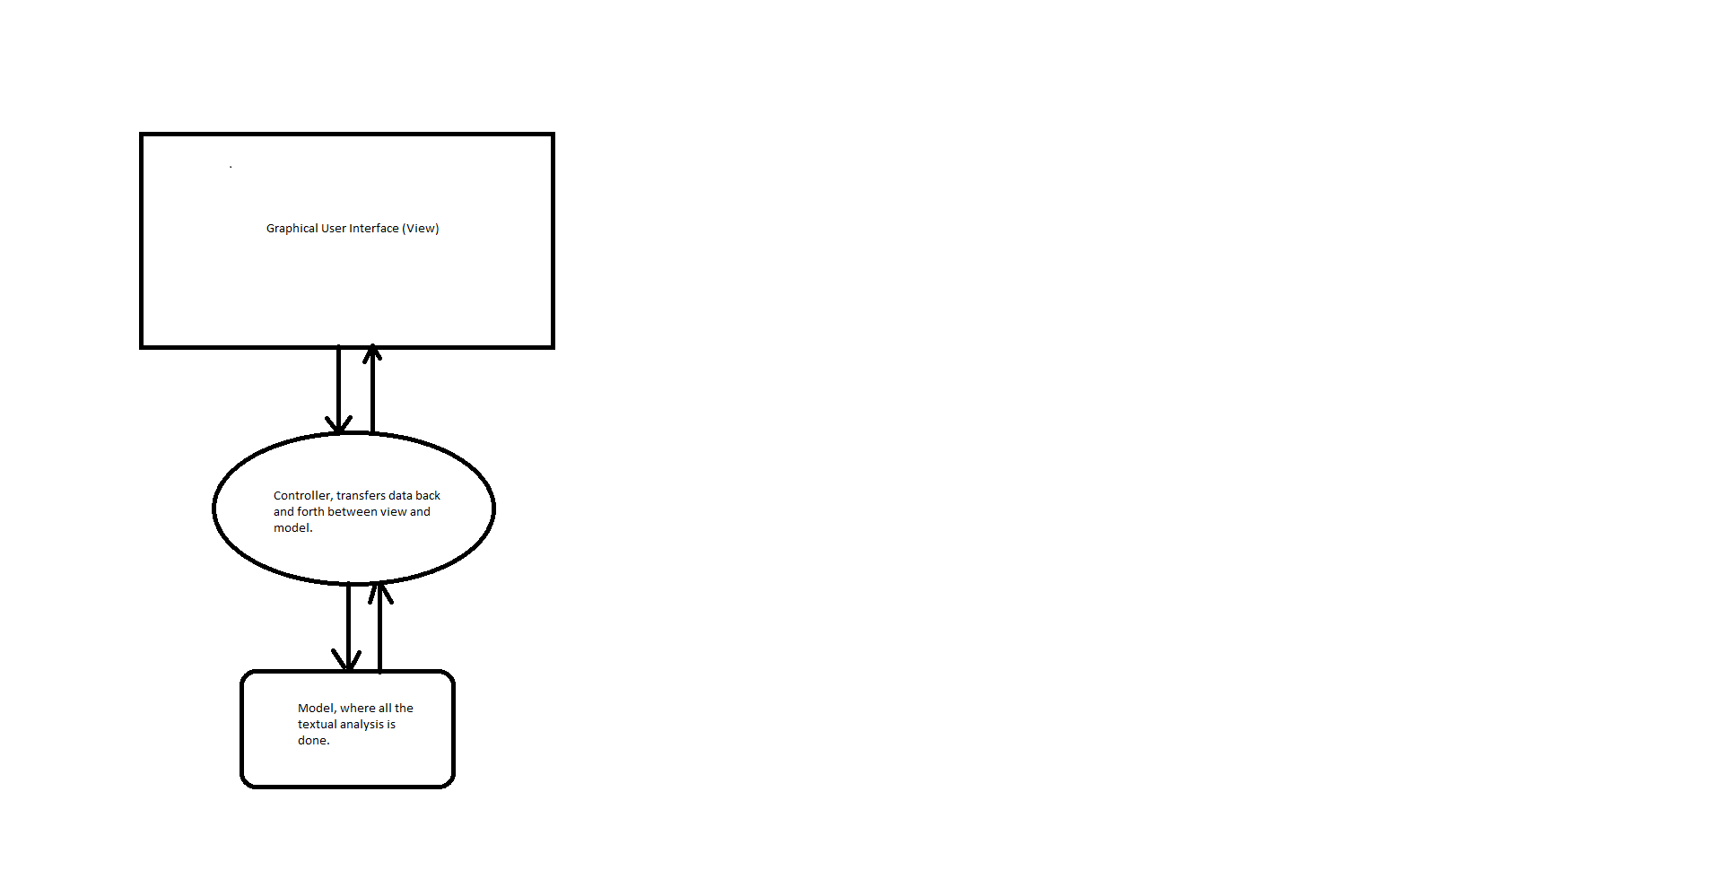**View:** This is the graphical user interface, this is where the user will interact with the program.

Model:

Classes:

1. **View Classes:** 
   1. **System:** This python file, will be used to craft and develop the entire graphical system. It will prompt the user with certain interactions. It will use action listeners to gain data from the user.
      1. **Global Variables:**
         1. Reference to the controller, allow for transferring data back and forth from model to the view.
      2. **Methods:**
         1. **BuildMainMenu():** Builds the main menu for users to interact with, look at the GUI section on how this will roughly look like.